Title or Task: |   

Description:

Files Required
Suitable for Classes: | AIT • Multimedia • Cert II IT • Cert II Bus
Area: | Technology & Enterprise
Teacher: | Mr Peter Faulks

Timeline

Date Due:
Task Brief: | In class lesson

Outcomes:

Items highlighted in yellow are tasks for you to complete
Items in Blue italics are help tips

SOLUTIONS
See completed page
http://peterfaulks.net/Teaching/Student_Compendium/SC015_Government.htm
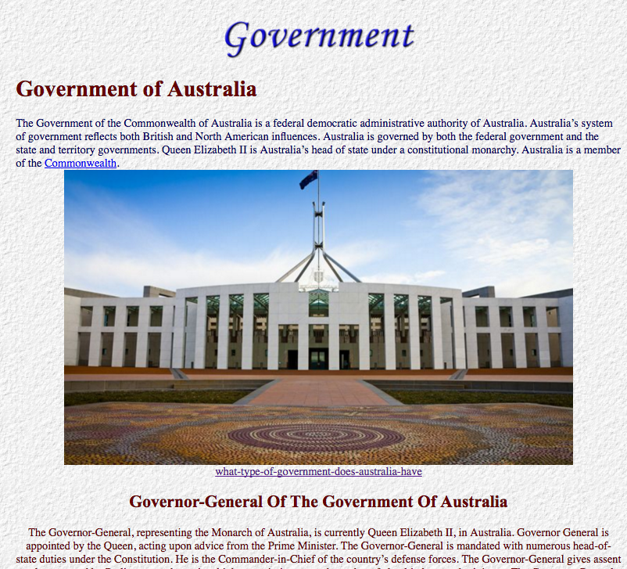

PERTAINING TO GOVERNMENT
Government of the people, for the people and by the people | Democracy
Government by a Sovereign of uncontrolled authority | Autocracy, despotism
Government by the nobility | Aristocracy
Government by departments of state | Bureaucracy
Government by a few | Oligarchy
Government by the wealthy | Plutocracy
Government by priests or ecclesiastics | Hierarchy, hagiocracy, hagiocracy
Government by divine guidance | Theocracy
Government of the church by bishops | Episcopacy
Government by a military class | Statocracy
Government by the worst citizens | Kakistocracy
The right of self government | Autonomy
The science of government | Politics
Sweeping governmental changes | Revolution
To decide a political question by the direct vote of the whole electorate | Referendum
The period between two reigns | Interregnum
One who governs a kingdom during the infancy, absence, or disability of the sovereign | Regent
The wife or husband of a king or queen | Consort
An official numbering of the population | Census
Facts and figures | Statistics

Australian Government

Federation
The Commonwealth of Australia was formed on 1 January 1901 when six partly self governing British colonies united to become states of a nation. The rules of government for this new nation were enshrined in the Australian Constitution- external site, which defined how the Commonwealth government was to operate and what issues it could pass laws on.
The birth of our nation is often referred to as 'federation' because the Constitution created a 'federal' system of government. Under a federal system, powers are divided between a central government and individual states. In Australia, power was divided between the Commonwealth federal government and the six state governments.

Australian government
The Australian Parliament- external site consists of the Queen (represented by the Governor-General), the Senate and the House of Representatives. The Parliament passes laws which affect the whole country. Section 51 of the Constitution defines a number of issues that the Parliament can make laws on.
There are three arms of government in Australia:
- the legislature (or Parliament) is responsible for debating and voting on new laws to be introduced under the power of section 51.
- the executive (the Australian Government) is responsible for enacting and upholding the laws established by the legislature. Certain members of the legislature (called ministers) are also members of the executive, with special responsibilities for certain areas of the law.
- the judiciary is the legal arm of the federal government. It is independent of the other two arms, and is responsible for enforcing the laws and deciding whether the other two arms are acting within their powers.

State and territory government
Although the six states joined together to form the Commonwealth of Australia, they still each retain the power to make their own laws over matters not controlled by the Commonwealth under Section 51 of the Constitution. State governments also have their own constitutions, as well as a structure of legislature, executive and judiciary.
Territories are areas within Australia's borders that are not claimed by one of the six states. Territories can be administered by the Australian Government, or they can be granted a right of self-government.
There are eight Australian territories in addition to the Australian Capital Territory (ACT) and Northern Territory (NT): Ashmore and Cartier Islands, Australian Antarctic Territory, Christmas Island, Cocos (Keeling) Islands, Coral Sea Islands, Jervis Bay Territory, Norfolk Island and Territory of Heard Island and McDonald Islands. These territories are governed according to Commonwealth law and the laws of a state, the ACT or NT. Most have an appointed Administrator. Norfolk Island is no longer self-governing. The Norfolk Island Legislation Amendment Bill 2015 has replaced the Norfolk Island Legislative Assembly and an elected Regional Council will be established on 1 July 2016.
Unlike the states, whose powers are defined through the Constitution, the powers of these territories are defined in Commonwealth law which grants them the right of self-government. This also means that the Parliament can alter or revoke these powers at will. Under Section 121 of the Australian Constitution- external site, territories can become states with the approval of the Parliament.
State and territory government provides more information on the six state governments, the federal-state relationship, and the government of Australia's territories.

Local government
Constitutional responsibility for local government lies with the state and territory governments. Consequently, the roles and responsibilities of local government differ from state to state. Local governments are also known as local councils.

GOVERNMENT OF THE UNITED KINGDOM
The Government of the United Kingdom is vested in the Queen, and the Two Houses of Parliament—The House of Lords and the House of Commons.
The Queen: The Executive function of the Queen or Crown is really performed by the Ministry—the body of Ministers who act in the Queen's name. However, before a Bill becomes law it has to receive the Queen's approval or Royal Assent as it is called. By custom or convention once a Bill has passed through both Houses of Parliament the Queen never refuses to assent to it. The last occasion on which a Sovereign exercised the Veto was in 1707 when Queen Anne refused to assent to the Scotch Militia Bill.
The House of Lords:
The House of Lords or Upper House is comprised of:
- The Lords Spiritual. These are the Archbishop of Canterbury, the Archbishop of York, the Bishops of London, Durham, and Winchester and twenty-one Senior Bishops. There are 26 Lords Spiritual.
- The Lords Temporal, who comprise:
(a) English Peers; (b) Peers of Great Britain; (c) Peers of the United Kingdom; (d) Sixteen Scottish Representative Peers; (e) Twenty-eight Irish Peers elected for life.
(c) Lords of Appeal in Ordinary: Seven Lords of Appeal in
ordinary, or Law Lords who are appointed to serve as
permanent Judges in the House of Lords Judicial Committee,
which is the Highest Appeal Court in the British Empire.
There are more than 800 members in the House of Lords. They are graded thus—Dukes, Marquises, Earls, Viscounts, Barons. Since 1911 the House of Lords has no power to stop a Money Bill passed by the House of Commons, and since 1949 it has only a suspensive veto of one year over other Bills. In other words the Lords can delay any measure (other than a Money Bill) passed by the House of Commons from becoming law for a period of one year

The House of Commons is the third and most important Estate of the Realm. It is referred to as the Lower House although the House of Commons stands on the same floor as the House of Lords in the Parliament Buildings.
The members of the House of Commons are all elected on an almost universal franchise. Every person can exercise the vote (provided he or she is not legally disqualified) so long as that person is a British Subject who has attained the age of twenty-one, and has the necessary residence or business qualification.
The House of Commons consists at present of 630 members. These members are returned to Parliament as representatives of either Boroughs, or Counties.
Party Government. The real Government of Great Britain, however, is the party, which has a majority in the House of Commons. There are three main Parties in Parliament—the Conservative Party, the Labour Party and the Liberal Party—and the Government is named after the Party, which gains the most seats at a General Election. The present Government (in 1957) is the Conservative Government.
The Prime Minister. As soon as the results of a General Election have been declared Her Majesty sends for the leader of the Party, which has a majority in the House of Commons and asks him to form a Government. This Party Leader henceforth becomes the Prime Minister.
The Ministry and Cabinet. The Prime Minister then selects about fifty or sixty persons from his own Party who are members of one or other of the Houses of Parliament and appoints them as Heads of the Chief Departments of State. The Queen makes these Ministers of State Privy Councilors if they are not so already, and they form what is known as the Ministry.
From this large body of Ministers the Prime Minister selects a small group representing the ablest and perhaps the most experienced members, and these, with himself as head, form the Cabinet. The Cabinet usually consists of between 20 and 22 members.
The following Ministers are usually in the Cabinet. The Lord Chancellor, the First Lord of the Treasury, the eight Secretaries of State, the Chancellor of the Exchequer, the Lord President of the Privy Council.

The history of the Cabinet System is interesting. From earliest times the Sovereigns of England had a body of trusted advisers who became known as PRIV Y Councilors. When King Charles II came to the throne he found this large body of Privy Councilors too unwieldy. As he did not care to discuss important matters of state with so many Councilors he selected a few of his favorites from among them as his closest advisers and would consult them before presenting any matter to the Privy Council. These used to meet in the King's Cabinet, hence the name CABINET.

This action of the King was very unpopular and the Cabinet was contemptuously referred to as the CABAL, a word formed from the initial letters of the surnames of the King's favorites—Clifford, Arlington, Buckingham, Ashley, Lauderdale. Nevertheless the Cabinet system continued to grow.
George I and George II were Germans who succeeded to the throne of England. As they could not speak English they ceased to attend Cabinet Meetings and delegated the minister who commanded the respect of his colleagues to preside at the Cabinet Meetings in the King's stead. This PRIME MINISTER afterwards reported the decisions of the Cabinet to the King. From that time the Sovereign has never presided at a Cabinet Meeting and it has now become an established custom that he should not do so.

CIVICS
Civics has been defined as the science of citizenship and municipal government. The Study of Civics in Schools is intended to help children to become " upright and useful members of the community in which they live, and worthy sons and daughters of the country to which they belong."
THE BRITISH COMMONWEALTH OF NATIONS
The British Empire or the British Commonwealth of Nations, of which we form a part, is the greatest Empire the world has ever seen.
It consists of:
- The United Kingdom which comprises (a) Great Britain (England, Wales and Scotland); (b) Northern Ireland; (c) The Channel Islands and the Isle of Man.
- The Self-Governing Dominions of Canada, Australia, New Zealand, the Union of South Africa, Ceylon and Ghana. (India and Pakistan are in the unique position of being Republics within the Commonwealth.)
The Dominions are territories within the British Empire, which enjoy full self-government or Dominion Status. In the words of the Balfour Declaration—The Dominions are "autonomous communities within the British Empire, equal in status, in no way subordinate, one to another in any aspect of their domestic or external affairs, though united by a common allegiance to the Crown, and freely associated as members of the British Commonwealth of Nations."
(3) Crown Colonies. These are the non-self-governing
territories of the British Empire. They are administered by Governors appointed by the Secretary of State for the Colonies. In the more advanced Crown Colonies the Governor is assisted by an Executive Council and a Legislative Council, which may be wholly, or partly elected and/
or wholly or partly nominated.

THE PRIVILEGES OF A CITIZEN
I.
Perhaps the greatest privilege of a citizen is his right to share in the government of the country. He can do so by his vote.
In the eyes of the law all citizens are, broadly speaking, equal. Whatever our station in life, whether rich or poor, all of us are liable to punishment in the ordinary courts of law for breaches of the law.
- Unless he has been suspected of committing a felony a constable may not arrest a citizen without a warrant.
- No citizen can be legally punished or deprived of his possessions except by the decisions of the ordinary courts of law.
- All citizens enjoy equal protection from the law. The protective hands of the Police Force are there for us all.
- Every citizen enjoys personal freedom: short of breaking the law he is free to do what he likes. If a citizen is wrongfully deprived of his liberty he can obtain redress by recourse to the law courts.
- Every citizen has a right to freedom of discussion. This means that he is free to say, write or publish anything he pleases so long as he does not commit a breach of the law.
The law is infringed if he says or publishes anything of a defamatory, seditious, blasphemous, or obscene character.
- Every citizen has the right to public meeting. People may meet together whenever or wherever they please in so far as they do not offend against the law. They can be apprehended for committing a nuisance, or trespass, or constituting an unlawful assembly. Also, the public have no right to meet in a public thoroughfare, or public resorts.
- Every citizen enjoys the right of self-defence. He is justified in using a proportionate amount of force in defence of himself, his wife, his children, his house, or his property.
THE RESPONSIBILITIES OF A CITIZEN
A. 1. A citizen's first duty is loyalty to his Queen and country. In exchange for the protection extended by the Queen every subject owes a " natural and legal obedience to her."
- It is the duty of the citizen to obey all the laws of the land.
- Since the revenue of Government is used to defray public expenditure, it is the duty of the citizen to pay all taxes and rates which he has to pay and not try to defraud the revenue.

- If called upon to help, it is the duty of every citizen to give active aid to the Police in the apprehension of offenders.
- The citizen must do all in his power to help suppress a riot, or other outbursts of disorder, or to help repel an invasion.
- It is his duty to aid the course of justice by giving evidence as a witness in criminal or police cases.
- He has a responsibility to register the birth of his children soon after they are born, to have them vaccinated, and to see that they receive elementary education.
B. The above are the legal statutory duties of a citizen, but it must not be supposed that the responsibilities of the citizen end with these. If a citizen faithfully adhered to the above he could be described as a law-abiding citizen. If he were apprised of all the information in the foregoing pages he might be considered an informed citizen. But these would not in themselves make him a good citizen.

It is important that the citizen should realise that he lives in a civilized society and that he has certain moral, social
and community obligations.

In times like these there is no place for the " lone wolf." Our actions are dependent on the actions of others with whom we have to associate. If therefore, we wish to be worthy citizens of our country, there are certain principles which we must try to observe. These are:

(1) Proper human relationship; (2) Service to the community.



